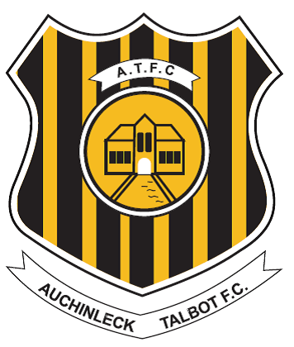

**Auchinleck Talbot Football Club**

**DISABILITY POLICY**

In accordance with the Equality Act 2010 (the Act), Auchinleck Talbot Football Club (hereafter referred to as the Club) is committed to ensuring that disabled customers have the best possible access to the goods and services provided by the Club.

The Committee regularly connects with our disabled supporters on issues and resolve matters as quickly as possible.

.

There is safe access to the ground for disabled spectators in wheelchairs and their companions equal access toilet provision is in place.

Refreshments, hot & cold food, are available the club will always provide a delivery service to supporters & visitors on request

Disabled customers who require assistance on entry to the ground, including wheelchair users, will be admitted through Gate 1. Entrance under the guidance of a match day Committee member.

Match day Committee members will always be on hand to advise and assist as and when required.

Club contact for assistance pre or post-match Campbell Peden [peden13@me.com](mailto:peden13@me.com) Tel:07714299673.

The club operate a concessionary ticketing policy for disabled supporters and will ensure that the scheme does not discriminate between disabled people with differing impairments. The Club will, in full consultation with our disabled supporters group continue to improve access to all facilities for our disabled customers

The Club will ensure that all Committee members are issued with a toolbox talk detailing the requirements of the Equalities Act, and ongoing consultations will be included at committee meetings.

The Club will provide guarantees to its disabled customers that any complaints, including those of discrimination, under the provisions of the act will be dealt with immediately and aim to resolve them as soon as possible and under the Club’s disciplinary procedures where required.

Should any supporter/visitor to Beechwood wish to discuss the above or any related issue the clubs Safety Officer can be contacted as detailed below:

Campbell Peden  
Ground/Matchday Safety Officer  
Email: peden13@me.com  
Mobile: 07714299673

The Club has a complaints procedure in place and guarantees to its disabled supporters and customers that any complaints of discrimination will be dealt with quickly under that procedure, complaints should be sent to the club’s secretary who is nominated individual for the implementation and annual review of this policy. The Club has advised its staff that any incident of discrimination under the provisions of the Act is a serious matter and will be dealt with under the Club’s Disciplinary Procedures.

The Club Secretary

Auchinleck Talbot F.C

16 Main Street

Auchinleck

KA18 2AR

Signed ……Henry Dumigan Club Secretary …..

The Club has made this policy available on the club's official website and keeps this policy under review, with additions or amendments made where deemed appropriate by the club, or under the advice of governing bodies or other relevant bodies.

Reviewed 2nd June 2024.

**STATEMENT- DISABILITY DISCRIMINATION ACT**